

FINISHED PRODUCT HAIRNET SPECIFICATION SHEET


HiCare

Certified and Approved by HACCP International

Material Prolen polypropylene yarn 56 decitex
(ISO 9001 and Okotex accredited supplier)
Elastic Nylon covered rubber. Min. 3x stretch
Width (qty of yarn strands) 103
Anti-Microbial Optional
Size (stretched) 22”
Fold and Hold Technology Patent Granted
Fabric Structure HairTite Standard
Weight 2 grams
Dye Fastness 4/5 grey scale C06A2S
Metal Detectable Same cost option for due diligence
Colours Blue, White, Red, Green, Yellow, Brown
Quantities Inner Outer Case
100 balled 1,000 or 4,000
2 x 50 card 3,000
3 x 48 card 2,880 or 7,200
Colours: Blue/White/Red/Yellow/Green/Brown
Other size options: 24” and 28”

FINISHED PRODUCT HAIRNET SPECIFICATION SHEET

HiCare

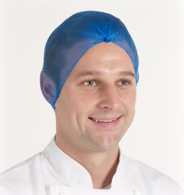

Features and Benefits: HAIRTITE HICARE

- Independently tested for hair containment by the University of Bolton UK
  - 2 X better hair containment than a traditional 3mm mesh hairnet
  - 4 X better hair containment when worn under a mob cap
  - 8 X better hair containment when worn under a KleenCap MAX

- Only hair containment product to be certified and approved by HACCP International as suitable for use within food processing and food service environments



- Tested for harmful substances in accordance with Oeko-Tex Standard 100
- Moisture wicking properties for optimum wearer comfort and temperature regulation
- Double Elastic
- Available metal free and metal detectable

For optimum hair containment read the White Paper Target Zero Hair Complaints @ www.aburnet.co.uk/target-zero-hair-complaints/

