RAMON (CHSA) BRAND LABEL

Ramon Product Code: KPY16

Stock/sales unit: per case of 30

Description: Size 16PY Kentucky Mop

Made in Pakistan

Mop Length: 79cm (Length may vary slightly to accommodate fluctuation in yarn count and maintain weight specification).

Mop Weight: 454g +/-3%

Yarn: 3 fold 0.85’s English Cotton Count
Minimum 80% cotton with 20% mixed fibres
Colour: ecru

Number of Ends: 180 (Number of ends may vary slightly to accommodate fluctuation in yarn count and maintain weight specification).

Centre Tape: 31mm wide
Printed with mop size and CHSA logo
100% cotton.
Colour: ecru

Sewing:
Stitching: Nylon thread

Colour Coding:

Colour coded Kentucky mops have 7.7cm of 13mm wide satin tape sewn into the centre band of the mop. The 4 colours of tape are: blue, green, red and yellow and are sewn in at one end only

Labelling:
Transit bar code: 5011251 016202

Packaging:

All packaging is recyclable and meets with the Packaging (Essential Requirements) Regulations 2003.
Details for Producer Responsibility Obligations (Packaging Waste) Regulations 2007 are as follows:-

Primary Packaging: Single mop per plain polythene bag
(Size: 470 x 200mm – weight: 6.5g)

Transit Packaging: 30 (6 bundles of 5) mops per cardboard carton
(Size: 500 x 400 x 360mm – weight: 1105g)
Gross weight: 14.9kg
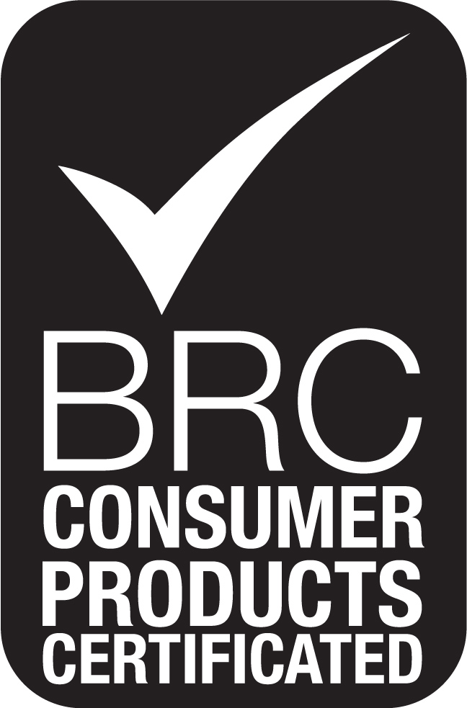
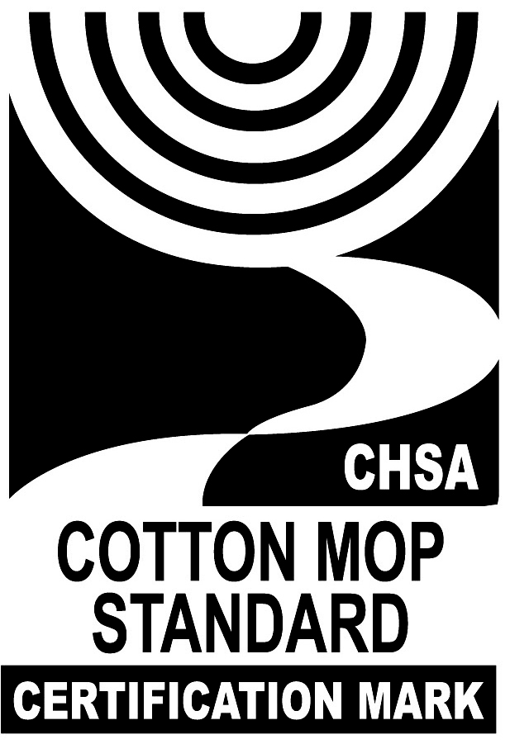

Palletisation: 24 cases per standard 4-way pallet
(4 layers of 6 cases)
Overall pallet height: 1.59m

