RAMON HYGIENE BRAND LABEL

Ramon Product Code: HB20W.24

(Stock/sales unit: per case)

Description: Economy Toilet Brush Set
Stiff Filament (Not Flagged)

Made in EEC
Size:
Overall Height: 380mm (15in)
122mm (4.80in) diameter

Filament Dimensions: 25mm (1.0in) long
0.50mm (0.02in) diameter

Colour: White

Material: Polyester

Approximate Weight: 165g

Labelling: Primary bar code: None
Outer case bar code: 5011251 044885

Packaging:

All packaging is recyclable and meets with the Packaging (Essential Requirements) Regulations 2013.
Details for Producer Responsibility Obligations (Packaging Waste) Regulations 2007 are as follows:-

Primary Packaging: None

Transit Packaging: 24 toilet brush sets in cardboard carton with internal separator
(size: 370 x 320 x 385mm – weight: 404g)

Internal cardboard separator
(size: 330 x 310mm – weight: 40g)
Gross weight: 4.4kg

Palletisation: 36 cases per standard 4-way pallet
(4 Layers of 9 cases)
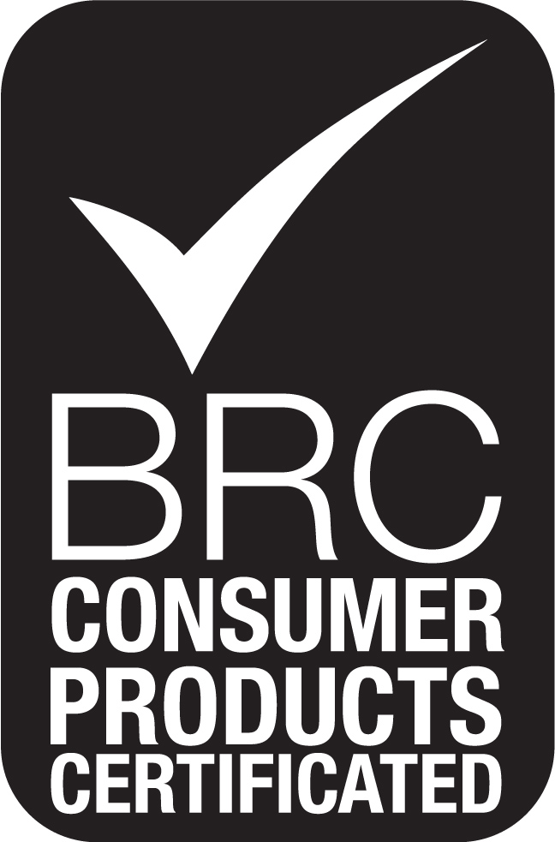
Overall Pallet height: 1.69m

