RAMON HYGIENE BRAND LABEL

Ramon Product Code: 802.CT
(Stock/sales unit: per case)

Description: Ramon ‘Contract’ 10 Pack Scouring Pads

Made in England
Approximate Size:

Length: 23cm +/- 2mm

Width: 15cm +/- 2mm

Thickness: 7 mm +/- 1mm

Approximate Weight: 15.87g per scourer approx. +/- 10% 460 gsm grade

Composition: Polyester fibre with acrylic resin, ground silica and pigment.

Colour: Green

Labelling: Pack bar code: 5011251 380358

Case bar code - Green: 05011251 380365.

Packaging:

All packaging is recyclable and meets with the Packaging (Essential Requirements) Regulations 2013.
Details for Producer Responsibility Obligations (Packaging Waste) Regulations 2007 are as follows:-

Primary Packaging: 10 scourers in printed polypropylene film
(size: 500 x 350 mm – weight: 4.2g)

Transit Packaging: 500 (50 x 10) scourers in cardboard carton
With adhesive outer label.
(size: 625 x 515 x 480mm – weight: 810.8g)
Gross weight: 8.9 kg approx.

Palletisation: 12 cartons per standard 4-way pallet
(3 layers of 4 cartons)

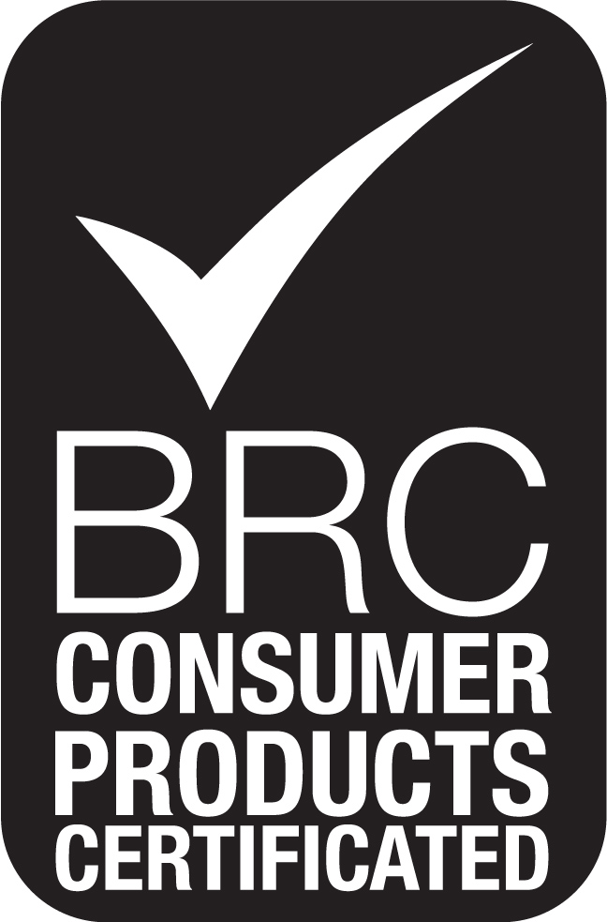
Overall pallet height: 1.62m

